Lift Every Voice and Sing II - #144 Where He Leads Me (VERSES 1,4)
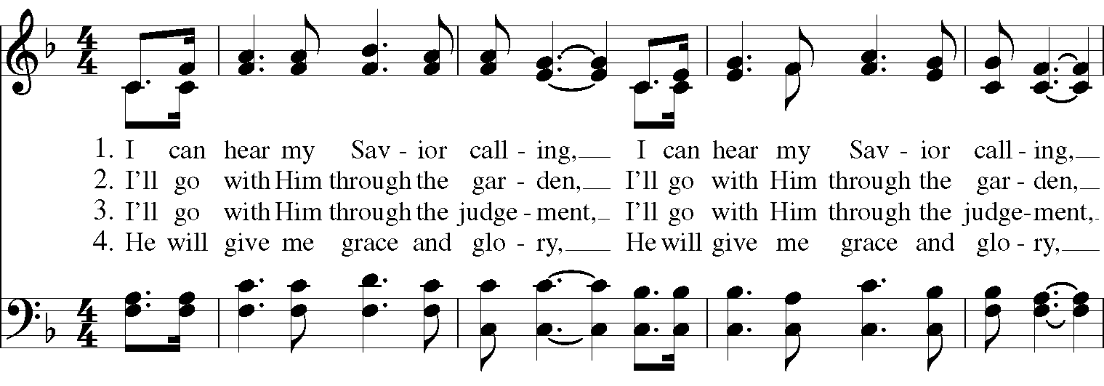
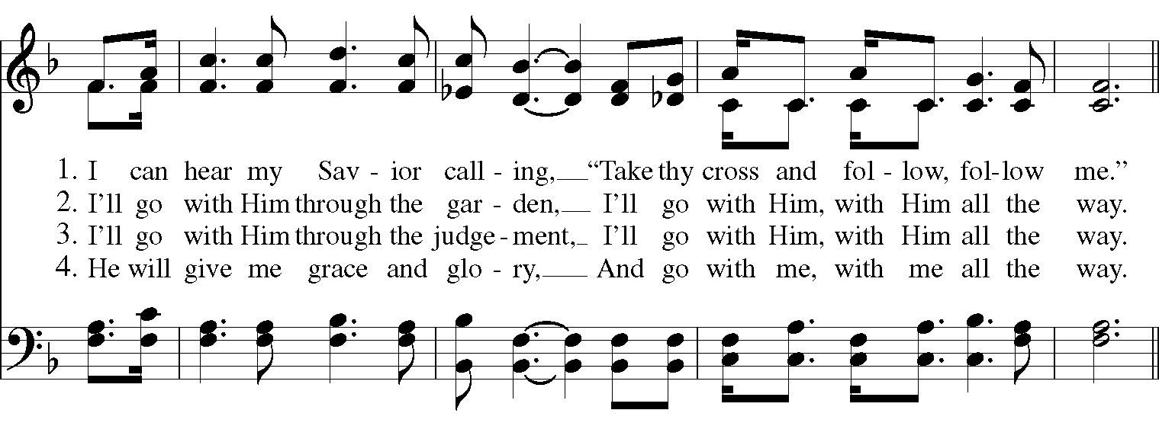
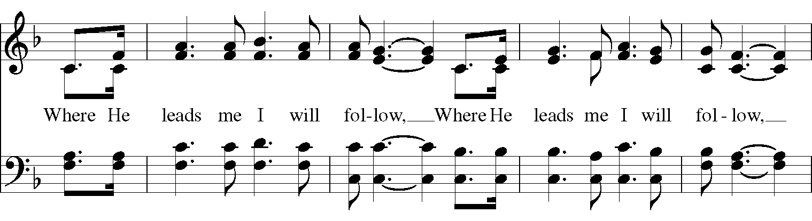
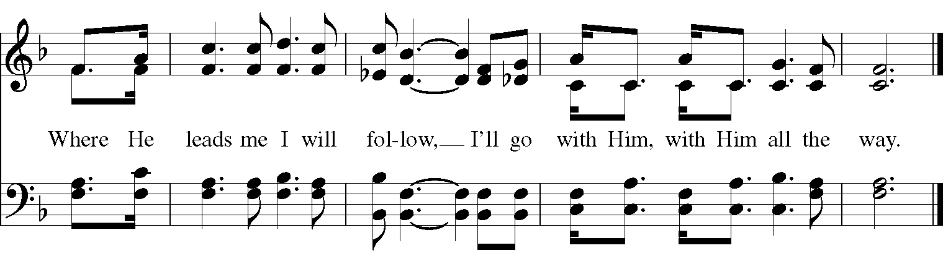

The Hymnal 1982 - #661 They cast their nets in Galilee (ALL VERSES)
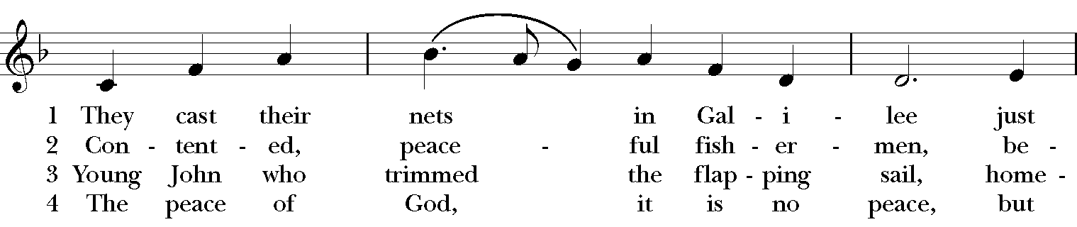
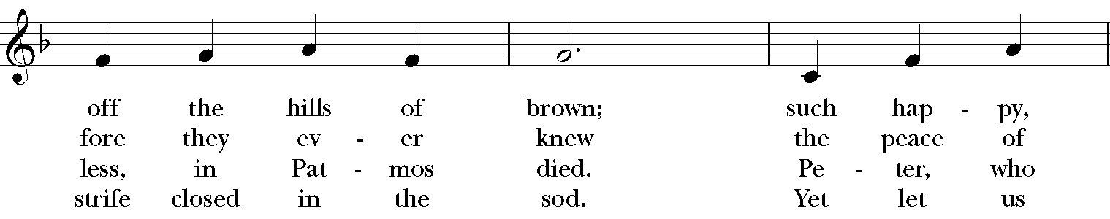
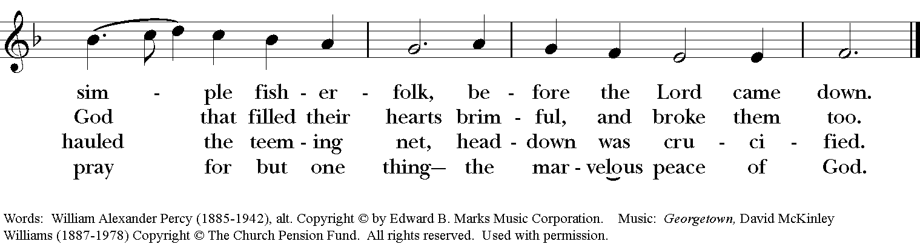

African American Heritage Hymnal - #567 I, the Lord of sea and sky (ALL VERSES)

I, the Lord of sea and sky, I have heard my people cry.
All who dwell in deepest sin my hand will save.
I who made the stars of night, I will make their darkness bright.
Who will bear my light to them? Whom shall I send?

Refrain:
Here I am, Lord. Is it I, Lord?
I have heard you calling in the night.
I will go, Lord, if you lead me,
I will hold your people in my heart.

I, the Lord of snow and rain, I have borne my people’s pain.
I have wept for love of them, They turn away.
I will break their hearts of stone, Give them hearts for love alone.
I will speak my word to them. Whom shall I send?
Refrain

I, the Lord of wind and flame, I will tend the poor and lame.
I will set a feast for them, My hand will save.
Finest bread I will provide Till their hearts be satisfied.
I will give my life to them. Whom shall I send?
Refrain

Words and Music: Daniel L. Schutte
Lift Every Voice and Sing #136: I have decided to follow Jesus (ALL VERSES)

I have decided to follow Jesus
I have decided to follow Jesus
I have decided to follow Jesus
No turning back, no turning back.

Though no one join me, still I will follow,
Though no one join me, still I will follow,
Though no one join me, still I will follow,
No turning back, no turning back.

The world behind me, the cross before me,
The world behind me, the cross before me,
The world behind me, the cross before me,
No turning back, no turning back.

Text: Ascribed to an Indian prince; as sung in Garo, Assam
Music: Indian folk melody; arr. Norman Johnson

