African American Heritage Hymnal- #131 Guide my feet

Guide my feet while I run this race,
Guide my feet while I run this race,
Guide my feet while I run this race,
For I don’t want to run this race in vain.

Hold my hand while I run this race,
Guide my feet while I run this race,
Guide my feet while I run this race,
For I don’t want to run this race in vain.

Stand by me while I run this race,
Guide my feet while I run this race,
Guide my feet while I run this race,
For I don’t want to run this race in vain.

I’m your child while I run this race,
I’m your child while I run this race,
I’m your child while I run this race,
For I don’t want to run this race in vain.

The Hymnal 1982 - #660 O Master, let me walk with thee (VERSES 1,3,4)
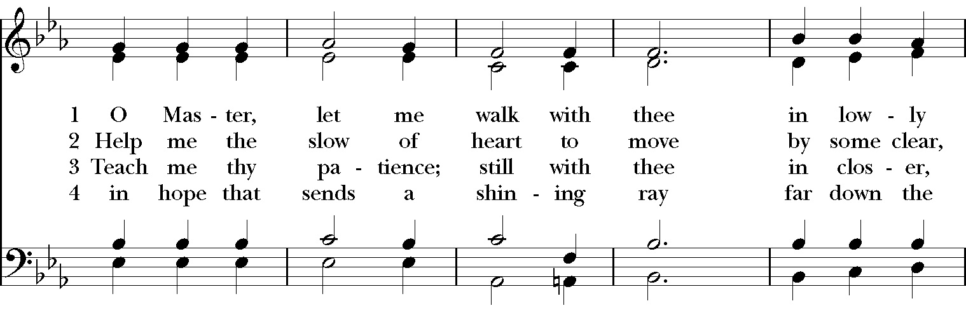
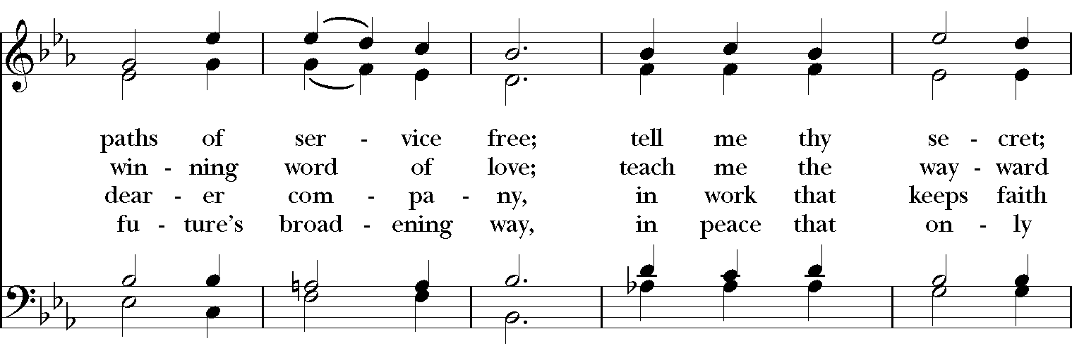
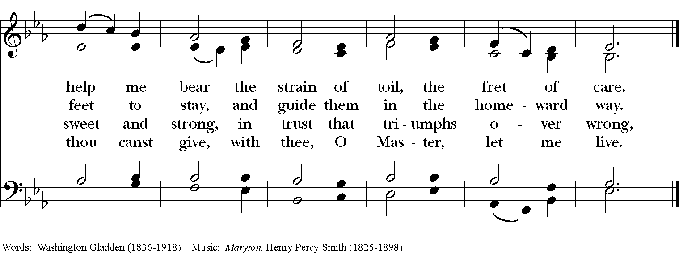

Lift Every Voice and Sing II- #194 Lead Me, Guide Me
Lead me, guide me, along the way,
For if you lead me, I cannot stray
Lord, let me walk each day with Thee.
Lead me, Oh Lord, lead me.
I am weak and I need thy strength and power
To help me over my weakest hour;
Help me through the darkness thy face to see,
Lead me, Oh Lord, lead me.
Refrain
I am lost if you take your hand from me,
I am blind without thy light to see;
Lord, just always let me thy servant be.
Lead me, Oh Lord, lead me.
Refrain
Words: Doris M. Akers (b. 1922)
Music: Doris M. Akers; arr. Richard Smallwood

The Hymnal 1982 - #707 Take my life, and let it be (ALL VERSES)
