The Hymnal 1982 - #490 I want to walk as a child of the light (VERSES 1, 2)
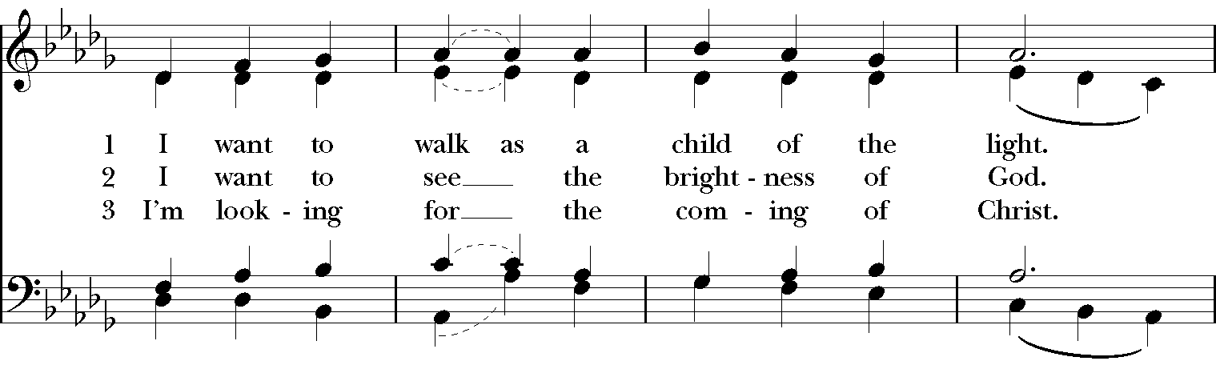
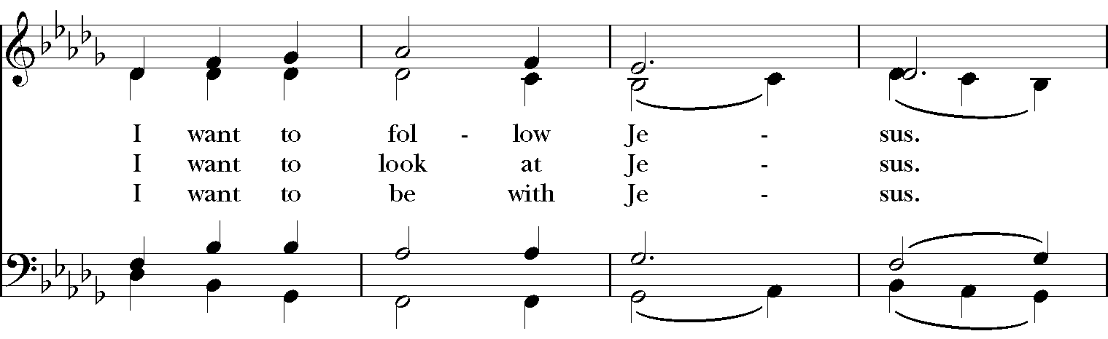
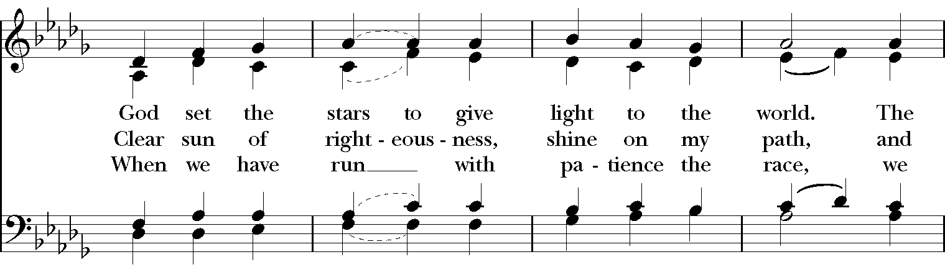
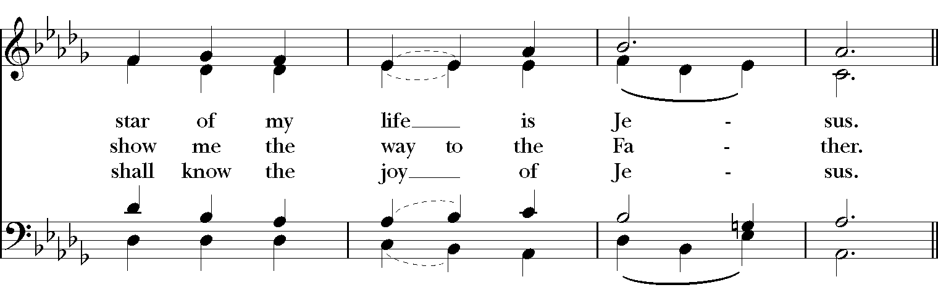
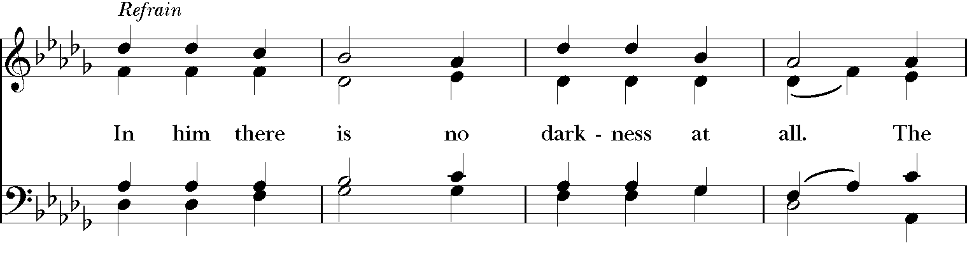
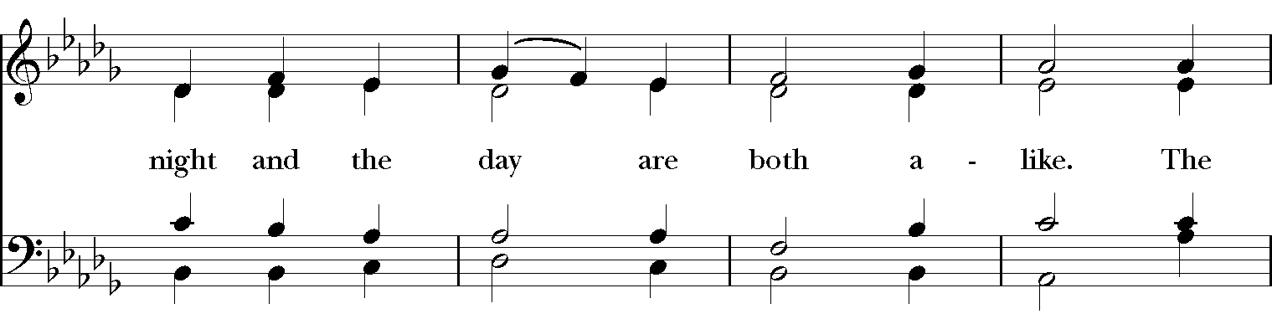
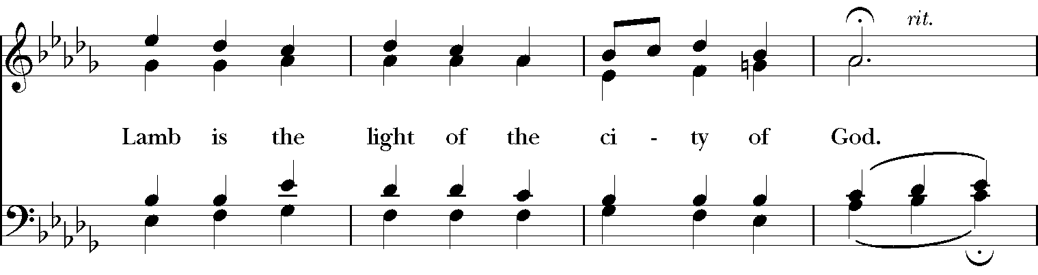
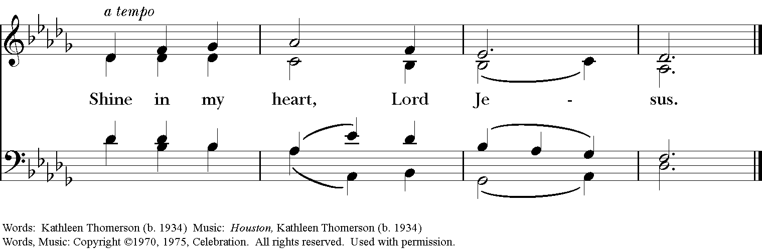

Lift Every Voice and Sing II - #103 Steal Away (VERSES 1,2,4)
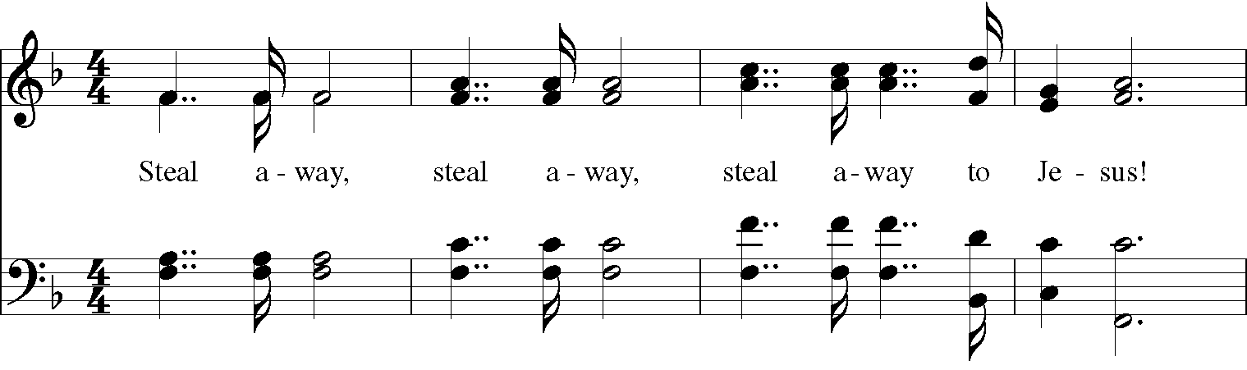
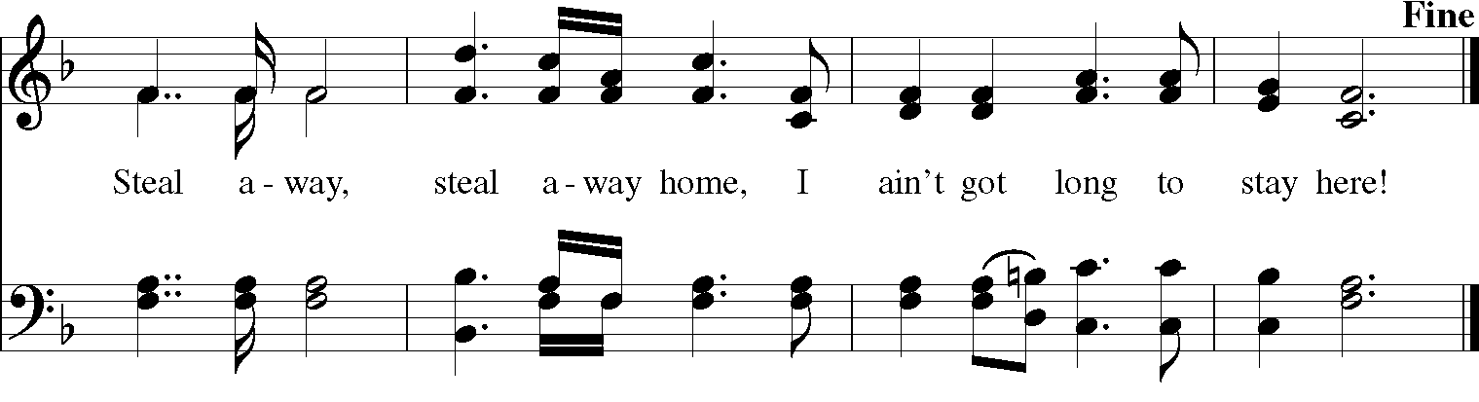
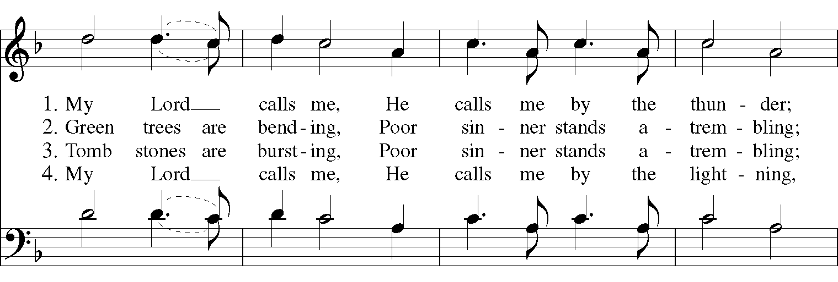
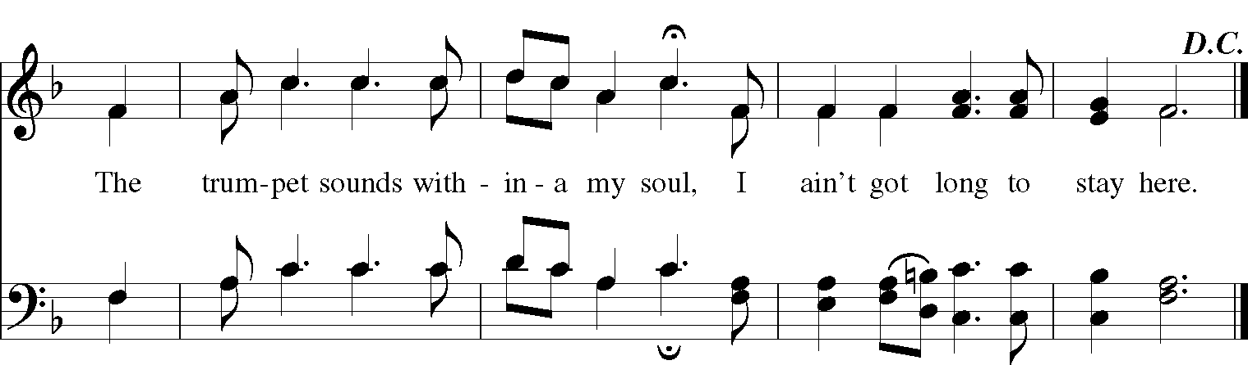

Lift Every Voice and Sing II - #18 Swing Low, Sweet Chariot (VERSES 1,2,4)
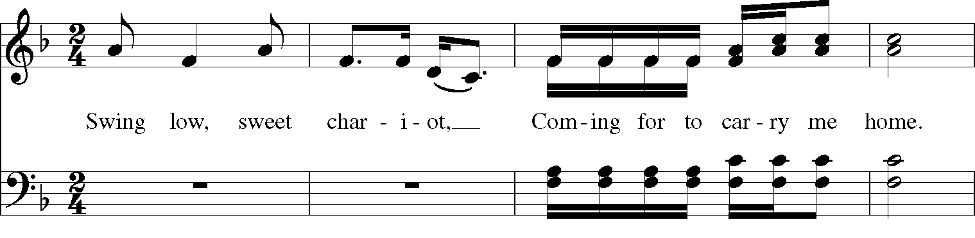
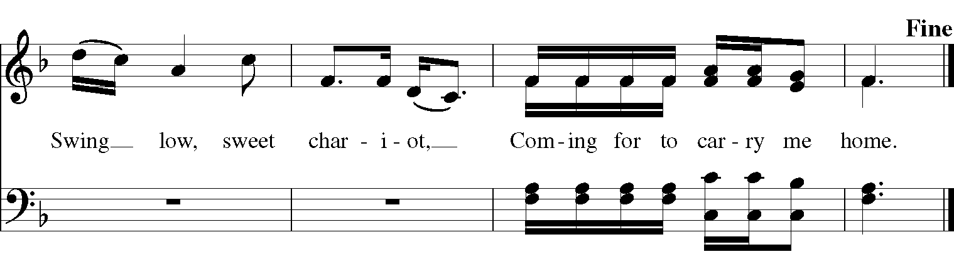
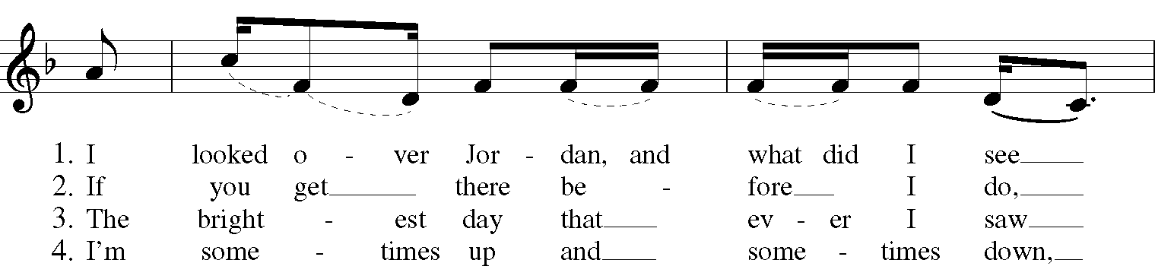
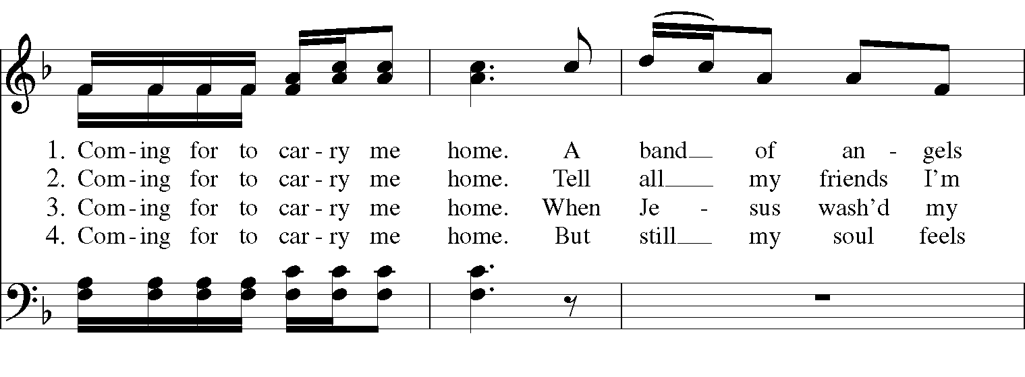
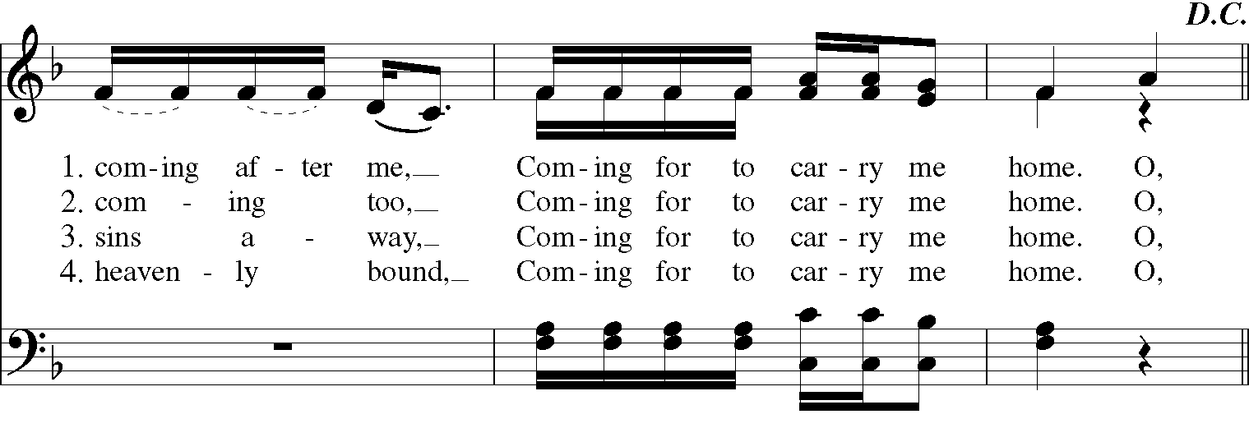

The Hymnal 1982 - #7 Christ, whose glory fills the skies (VERSES 1,3)
