Lift Every Voice and Sing II - #77 Jesus Is All the World to Me (VERSES 1,2,4)
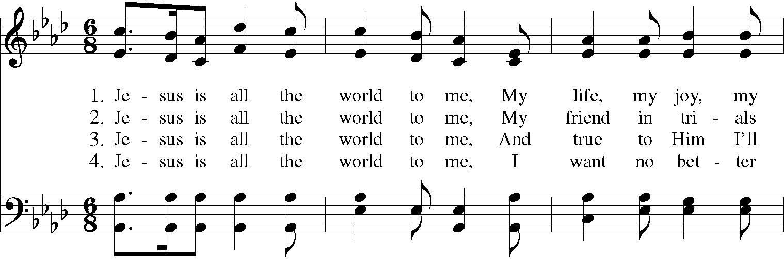
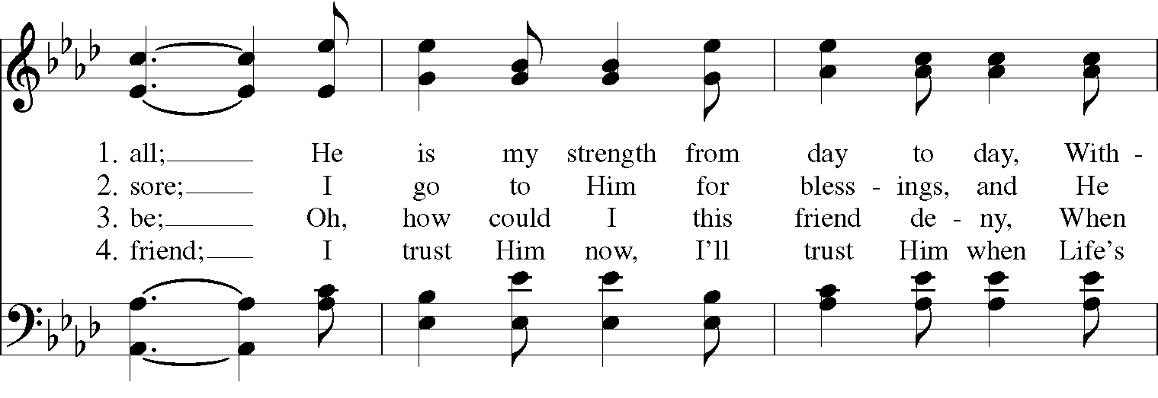
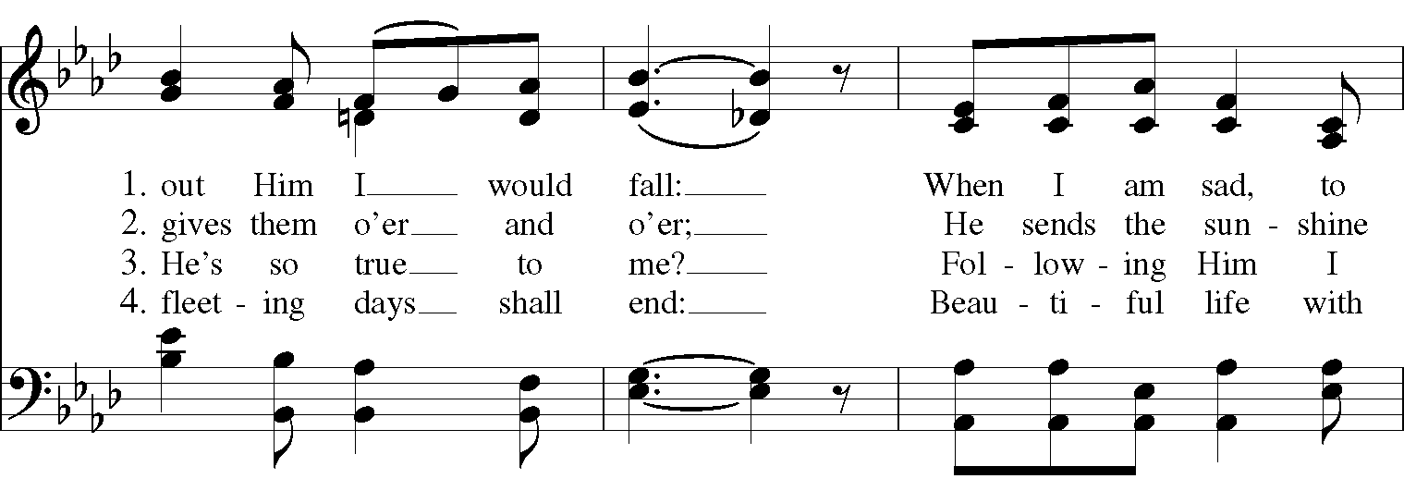
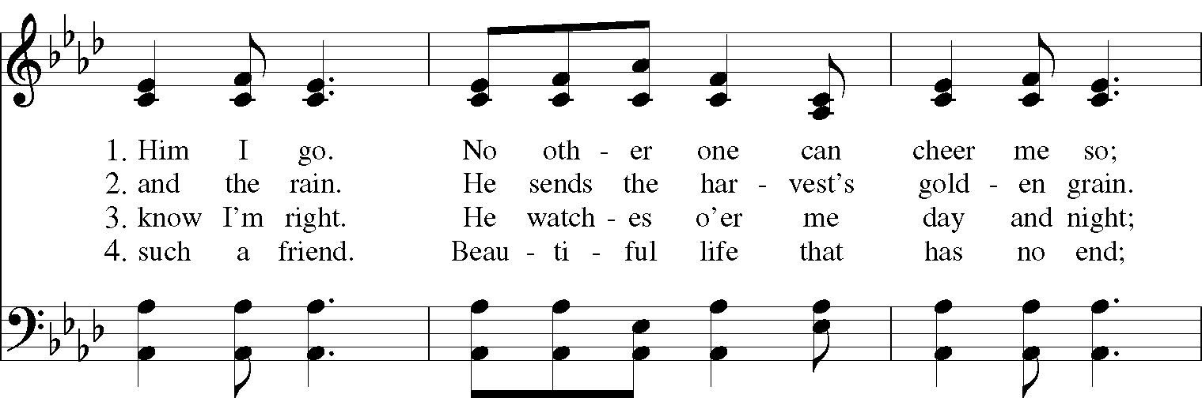
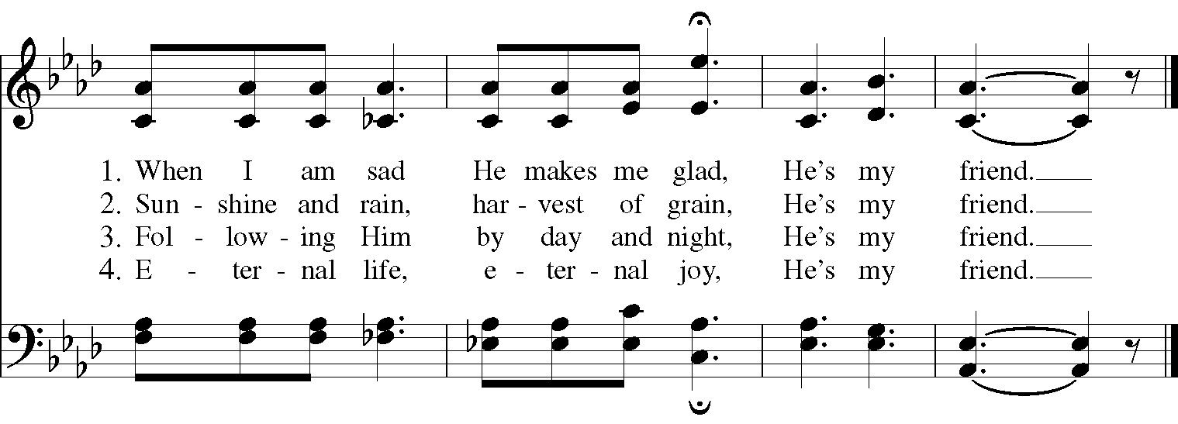

Lift Every Voice and Sing II: #62 In Christ there is no East or West

In Christ there is no East or West,
In Him no South or North;
But one great fellowship of love
Throughout the whole wide earth.

Join hands, disciples of the faith,
What e’er your race may be!
Who serves my Father as a son
Is surely kin to me.

In Christ now meet both East and West,
In Him meet South and North;
All Christly souls are one in Him
Throughout the whole wide earth.

Words: Galatians 3:28; adapt. John Oxenham (1852-1941)
Music: McKee, Negro Spiritual; adapt. Harry T. Burleigh (1866-1949)

Lift Every Voice and Sing II - #203 There is a Balm in Gilead (ALL VERSES)
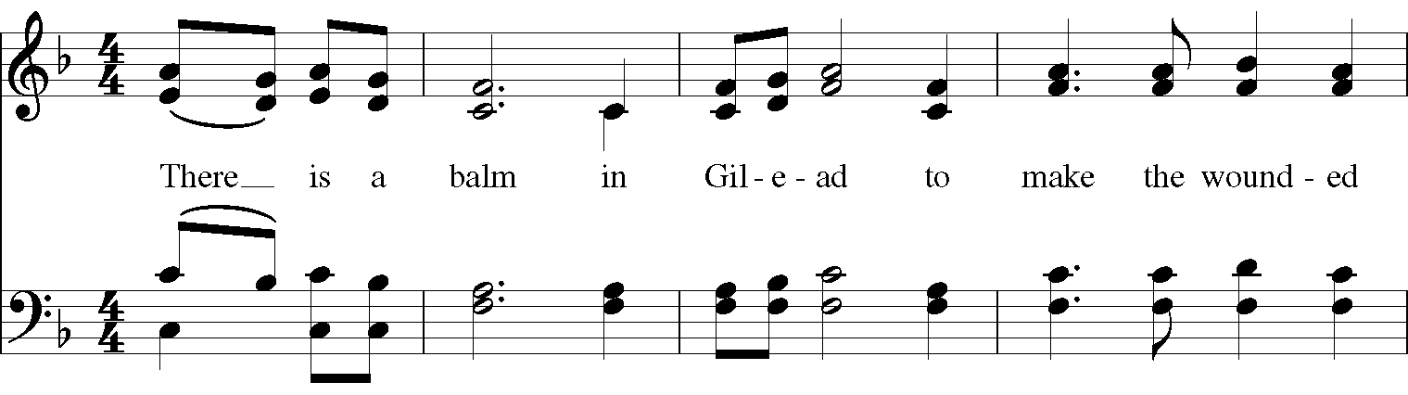
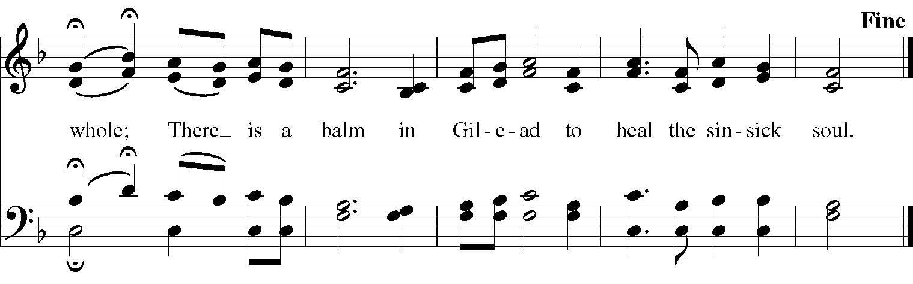
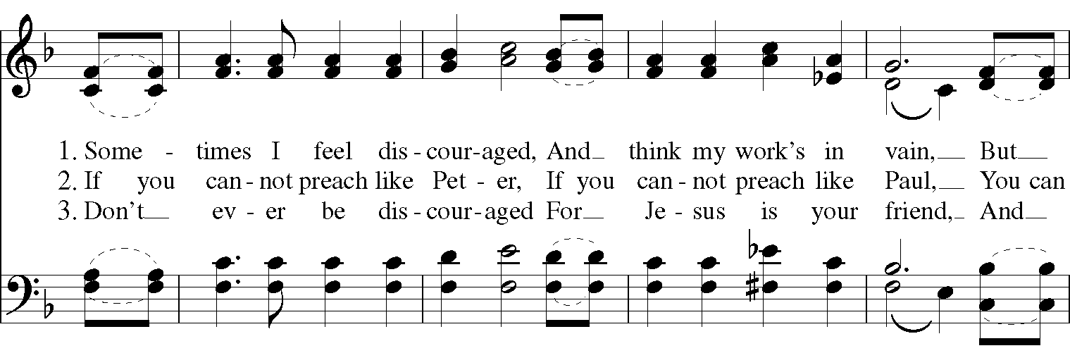
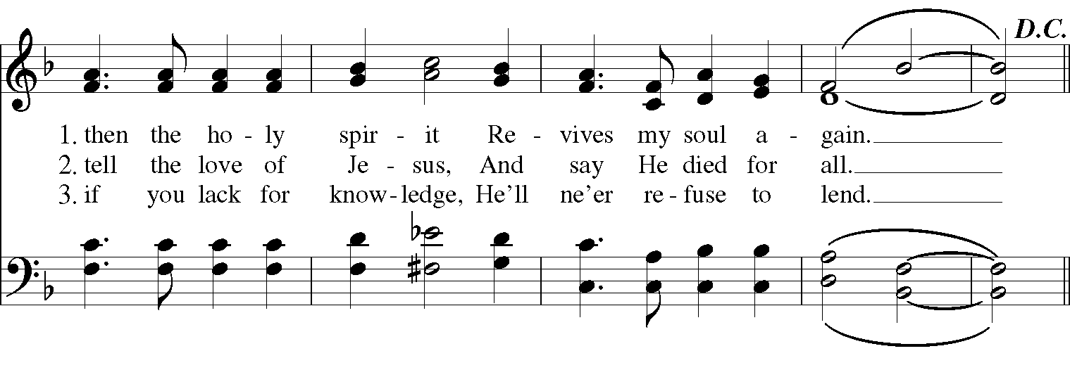

The Hymnal 1982 - #371 Thou, whose almighty word (VERSES 1,2,4)
